Midterm Evaluation: 30%

|  |  |
| --- | --- |
| **Course Identification** | |
|  |  |
|  |  |
| Course title: | **DATABASE** |
| Course number: | 420-921-VA |
| Group: | 070011 |
| Teacher’s name: | Alex Vilvert |
| Duration: | 210 minutes |
| Semester: | Summer 2024 |
| **Student Identification** | |
| Name: ____Julian David Hernandez Leon_____ Student number: ___2305009___  Date: _____19 / 06 / 24_______ Result: ______________  I declare that this is an original work, and that I credited all content sources of which I am not the author (online and printed, images, graphics, films, etc.), in the required quotation and citation style for this work. | |
| **Standard of the Evaluated Competency** | |
|  | |

|  |  |  |  |  |  |  |  |  |  |  |  |  |  |
| --- | --- | --- | --- | --- | --- | --- | --- | --- | --- | --- | --- | --- | --- |
| **- Develop non-transactional Web applications - 00ST**   | ***Evaluated elements of the competency*** | | ***Relevant performance criteria specific to each element*** | | | --- | --- | --- | --- | | 4. Program the Web interface.  6. Program the client-side application logic. | | 4.1 Appropriate use of markup language  4.2 Suitable creation and use of style sheets  4.3 Proper integration of images  4.4 Adaptation of the interface based on the display format and resolution  6.1 Correct manipulation of DOM objects  6.2 Proper programming of interactions between the Web interface and the user  6.3 Proper programming and integration of animations and widgets | | |  | |   **Conditions for the Completion of a Sole Course, or the Last Course within a Sequence of Courses, to Develop a Competency**  A sole course to develop a competency, or the last course within a sequence of courses, to develop a competency, can only be completed if the student meets the following two conditions:   * Receive a cumulative grade, including the final evaluation, greater than or equal to 60%. * Obtain a grade higher than or equal to 60% for the final evaluation.   Essentially, the failure of the final evaluation results in the failure of this course; even if the student’s cumulative grade, including the final evaluation, is greater than 59%. In such a case and when the evaluation constitutes an exam, the student has the right to take a supplemental evaluation. However, when the evaluation constitutes a project (the whole process or part of it outside of the classroom), the student may request a revision of his/her final grade as stipulated by Article 5.19 of the Institutional Policy on Evaluating Learning (IPEL).   |  | | --- | | **Instructions** | |  | | Permitted equipment: CalculatorClass notes are not allowed and students may not use the dictionary.No break is allowed during this exam. Students are not allowed to exit the examination room before half of the allotted time has passed. Once a student has exited the classroom, he/she may not re-enter (IPEL – Article 5.12.4).The teacher will not answer questions during the exam.Students must remain silent during the exam.It is the teacher’s responsibility to identify language errors. If such errors are found, teachers may deduct up to 20% of the final grade (IPEL – Article 5.7).Plagiarism, attempts at plagiarism or complicity in plagiarism during a summative evaluation results in a mark of zero (0). In the case of recidivism, in the same course or in another course, the student will be given a grade of '0' for the course in question.(IPEL – Article 5.16).Please write clearly. | |
|  |
|  |
| **Mark Breakdown** |
|  |
| This evaluation is worth 100 points, distributed as follows:   * Design and create frontend webpage using For a total of 100 points   **TOTAL : 100 POINTS** |

**Study Case**

You were hired to build a webpage for a restaurant. Follow the assets below reproduce the website according classes techniques.



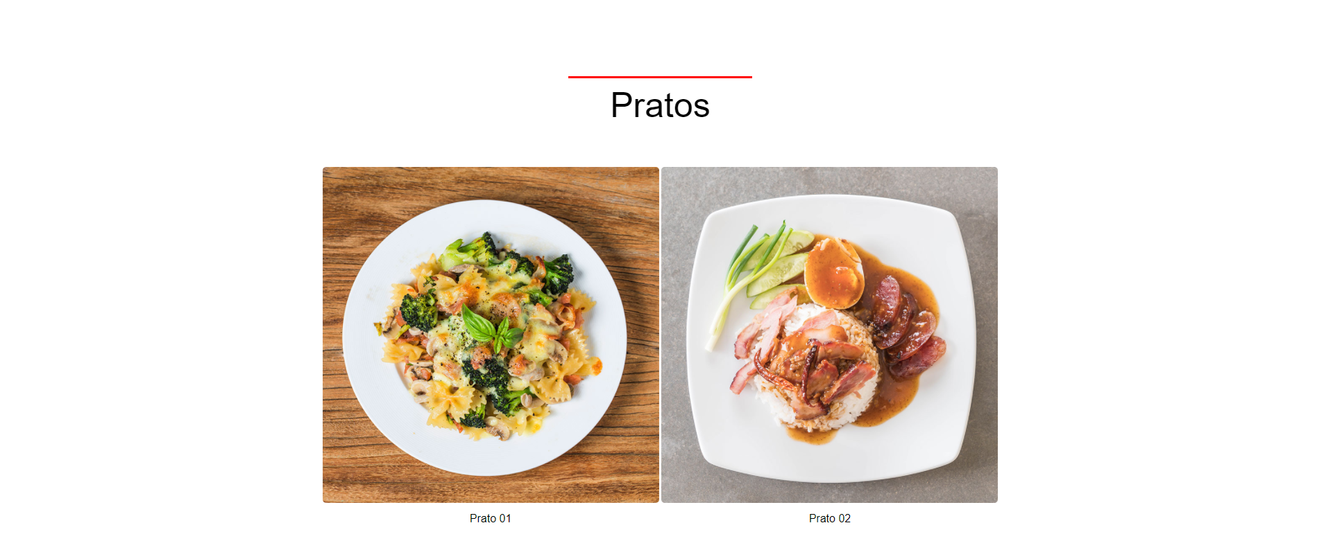

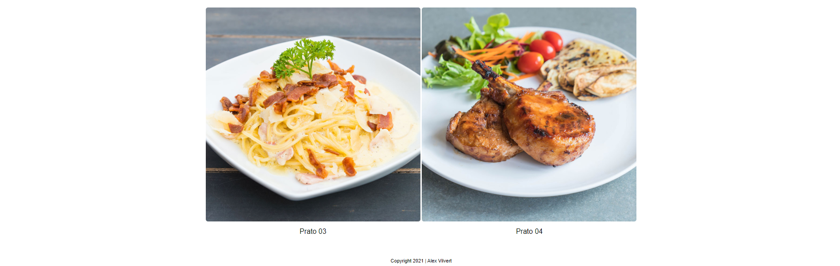

***Bonus question :***

***To no get 0 and fail on this exam, draw a picture of your teacher on vacation in Brazil with his new hair.***

|  |  |  |  |  |  |  |  |  |  |  |  |  |  |  |  |  |  |  |  |  |  |  |  |  |  |  |  |  |  |  |  |  |
| --- | --- | --- | --- | --- | --- | --- | --- | --- | --- | --- | --- | --- | --- | --- | --- | --- | --- | --- | --- | --- | --- | --- | --- | --- | --- | --- | --- | --- | --- | --- | --- | --- |
| **CORRECTION GRID FOR LANGUAGE**   |  |  |  |  | | --- | --- | --- | --- | | Clear Communication | Clear Communication, **most of the time** | Vague Communication | Unclear Communication | | - 0 | - 0,5 | - 1,5 | - 2 | | (Word Choice)  Use of precise and rich vocabulary | (Word Choice)  Use of precise vocabulary | (Word Choice)  Use of imprecise vocabulary | (Word Choice)  Use of inappropriate vocabulary | | - 0 | - 0,5 | - 1,5 | - 2 | | (Format/Type of work)  Respect of norms | (Format/Type of work)  Respect of **most of the** norms | (Format/Type of work)  Non-respect of the norms | (Format/Type of work)  Inappropriate in relation to the required norms | | - 0 | - 0,5 | - 1,5 | - 2 | | (Linguistic Code)  (≤2 mistakes / page) | (Linguistic Code)  (3-7 mistakes/page) | (Linguistic Code)  (8-10 mistakes/ page) | (Linguistic Code)  (>10 mistakes/  page) | | - 0 | - 0,5 - 2.5 | - 2.5 - 3.5 | - 4 | |

***Have Fun and Enjoy Life!***